OWASP & RAG Study Notes and System Architecture Design
AI Code Review & Security Analysis Agent — Milestone 1
Research Notes & Architectural Design Document
Student Name | RAVI KISHAN
Project Title | Development of Smart Code Inspection Platform with Vulnerability Detection System Group 1
Milestone | Milestone 1 (Week 1 - Week 2)
Scope of this Document | Research notes on OWASP & RAG, and system architecture design

Part A — OWASP Study Notes

A.1 What is OWASP
OWASP (Open Worldwide Application Security Project) is a nonprofit community that publishes freely available guidelines, standards, and tools for building secure software. Its most widely referenced publication is the OWASP Top 10, a ranked list of the most critical web application security risks. This project uses the OWASP Top 10 and OWASP Secure Coding Practices as the grounding standard for the Security Vulnerability Agent, so its findings are based on an established industry benchmark rather than arbitrary rules.

A.2 Core Vulnerability Categories Targeted by This Project
Vulnerability | Core Idea
SQL Injection | Occurs when untrusted user input is inserted directly into a database query without sanitization, allowing an attacker to alter the query's logic (e.g. bypassing login checks or extracting data). Prevention: parameterized queries / prepared statements.
Cross-Site Scripting (XSS) | Occurs when untrusted input is rendered in a web page without proper escaping, letting an attacker inject scripts that run in another user's browser. Prevention: output encoding and input sanitization.
Cross-Site Request Forgery (CSRF) | Tricks an authenticated user's browser into submitting an unwanted request to an application, exploiting the trust a site has in the user's session. Prevention: anti-CSRF tokens, same-site cookies.
Hardcoded Secrets | Passwords, API keys, or tokens embedded directly in source code, which can be exposed if the code is leaked or shared. Prevention: environment variables or secret managers.
Broken Access Control / Insecure Auth | Occurs when an application fails to properly restrict what authenticated users are allowed to do, letting users act outside their intended permissions. Prevention: enforce authorization checks server-side on every request.

A.3 Code Smell Patterns (Code Analysis Agent Reference)
Alongside security vulnerabilities, the platform also targets general code quality issues, known as "code smells" — patterns that don't necessarily break the code but indicate poor design and reduce maintainability:
- Long Method / Long Function — a function doing too many things at once, making it hard to test and understand
- Duplicate Code — the same logic repeated in multiple places instead of being reused
- Poor Naming — variables, functions, or classes named ambiguously (e.g. "data1", "temp")
- High Cyclomatic Complexity — too many nested conditionals/branches in one function, making logic difficult to follow and test
- Tight Coupling — components overly dependent on each other's internal details, making changes risky and hard to isolate

Part B — RAG Architecture Study Notes

B.1 What is RAG
Retrieval-Augmented Generation (RAG) is an architecture that combines a language model with an external knowledge source. Instead of relying purely on what the model "remembers" from training, the system retrieves relevant, factual documents at query time and provides them as grounding context before generating a response. This reduces made-up or outdated answers and lets the system's knowledge be updated simply by updating the document collection, without retraining the model.

B.2 Core Components of a RAG Pipeline
Component | Role
Chunking | Splitting large source documents (e.g. OWASP guidelines) into smaller, coherent sections so relevant portions can be retrieved individually rather than whole documents.
Embedding | Converting each chunk of text into a numerical vector that captures its meaning, allowing similarity to be measured mathematically rather than by exact keyword match.
Vector Store | A database (e.g. Chroma, FAISS) that stores these embeddings and allows fast similarity search to find the chunks most relevant to a query.
Retrieval | Given a new query (e.g. a flagged code issue), the system searches the vector store and pulls back the top-matching chunks of secure coding guidance.
Grounded Generation | The retrieved chunks are passed to the language model along with the query, so its response is grounded in real, retrieved guidance rather than memory alone.

B.3 Why RAG Fits This Project
The Security Vulnerability Agent and Conversational Code Assistant both need to give advice grounded in established secure coding standards, not just general knowledge. RAG allows the OWASP documentation to be indexed once, then retrieved on demand whenever a specific vulnerability type is being discussed — keeping the agent's advice consistent, verifiable, and traceable back to a real source document.

Part C — System Architecture Design

C.1 Agent Responsibilities
Agent | Responsibility
Code Analysis Agent | Reviews code structure; detects code smells, design anti-patterns, and complexity issues
Security Vulnerability Agent | Scans for OWASP-standard vulnerabilities, grounded in the RAG knowledge base
Remediation Agent | Generates corrected code examples and fix explanations per finding
PR Summary Agent | Compiles all findings into a structured, human-readable review summary
Conversational Code Assistant | RAG-powered Q&A for follow-up developer questions

C.2 Orchestration Flow (Sketch)
The diagram below shows how submitted code flows through the agent pipeline, and how the RAG knowledge base grounds both the Security Vulnerability Agent and the Conversational Code Assistant.
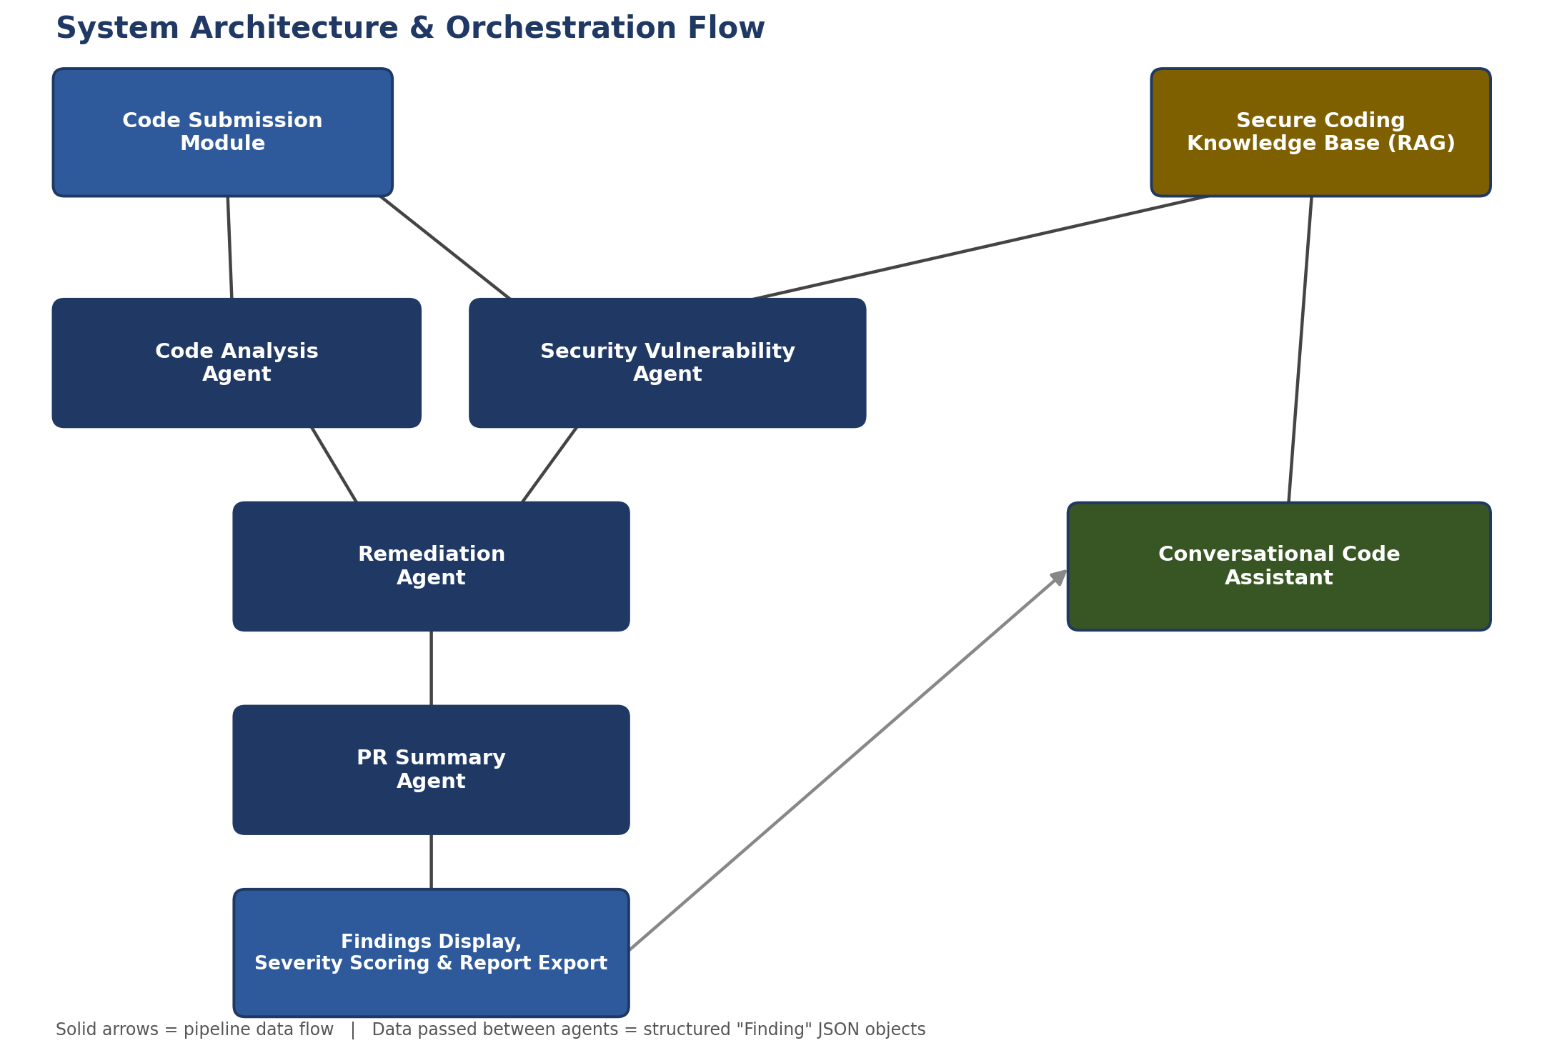

C.3 Core Data Model
A single structured object type is used to pass information between agents, ensuring predictable, machine-readable communication across the pipeline:
- Finding — { type, severity, affected_line(s), description, suggested_fix, source_agent }
Every agent that detects an issue (Code Analysis Agent, Security Vulnerability Agent) produces a list of Finding objects. The Remediation Agent consumes these and appends a suggested_fix. The PR Summary Agent consumes the enriched list and produces the final human-readable report.

C.4 Technology Stack Decisions
- Backend: FastAPI (Python) — lightweight, async-friendly, easy agent orchestration
- Vector Store: Chroma — free, local, simple to set up for a project of this scale
- Frontend: React — component-based UI for submission and findings display
- Development Environment: Google Antigravity — agent-assisted orchestration for building and testing the pipeline

